Courtney Powell

CIS 241- Documentation

The contents of this website is all related to me, Courtney Powell and the things I find interesting, important, or working towards. The home page is about me and my family.

The contents of the interests page is to learn about the things I like. I chose 4 sites that link to other sites ie; amazon, footlocker, Marilyn Monroe Bio, and Red Robin’s burgers. I also included on all of the pages individual glitter letters that spell out the name of the page the visitor is seeing. I chose the glitter because I really love glitter. Also each page has a different background theme. All of them of the sparkly nature.

The feature I like the best that was the hardest to learn to do was the hover over the images on my site with my kid’s name’s and age’s.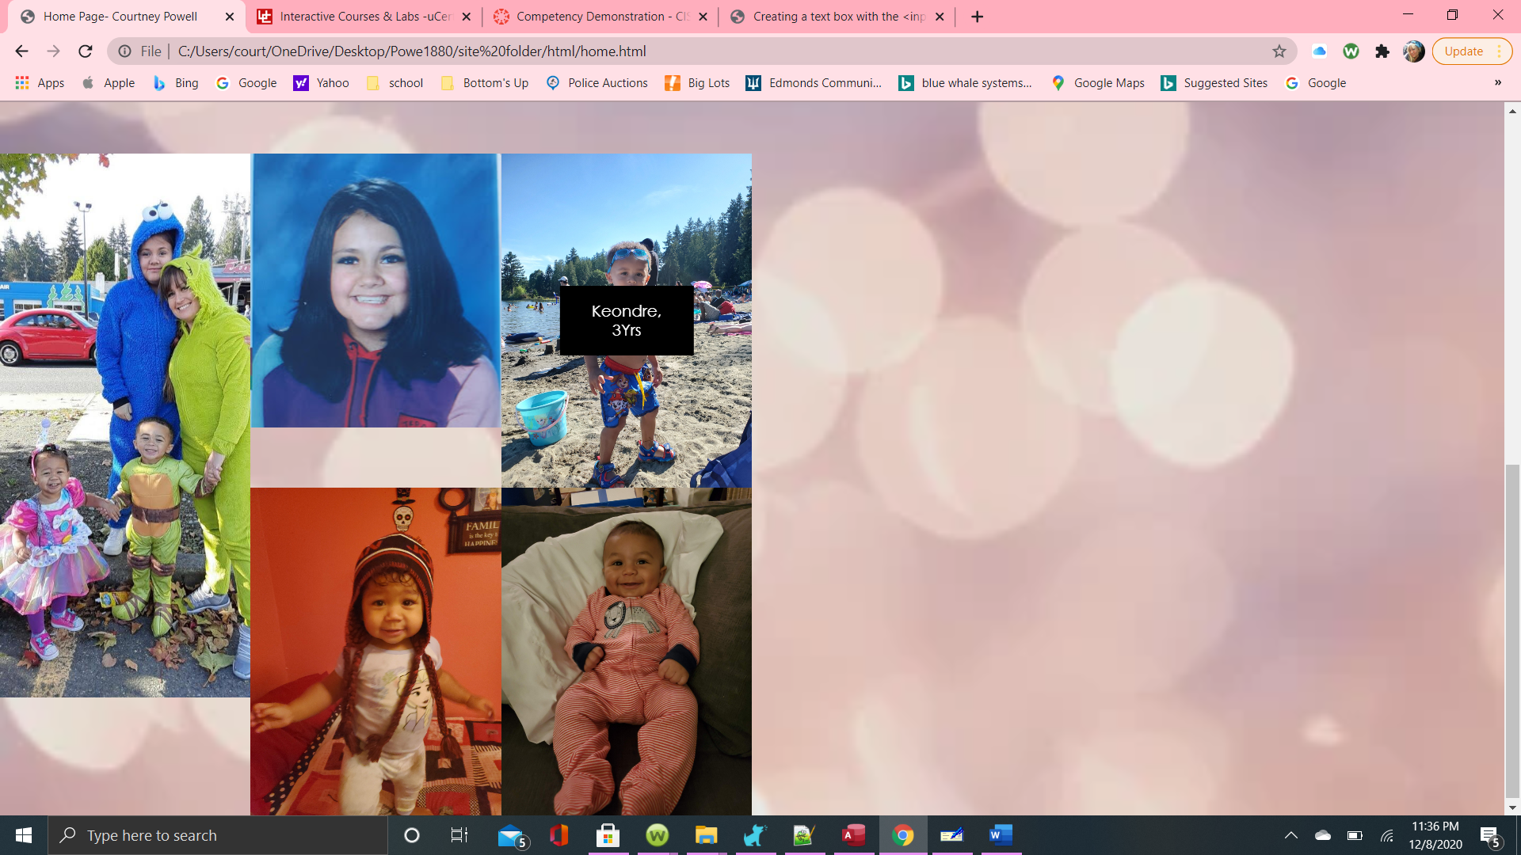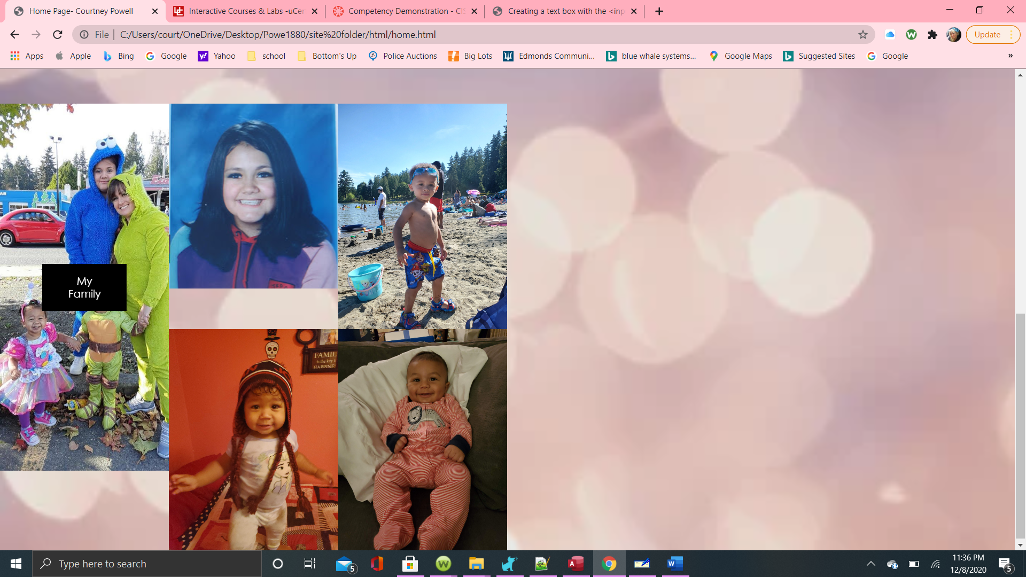

The pinky purpley sparkle is the home page.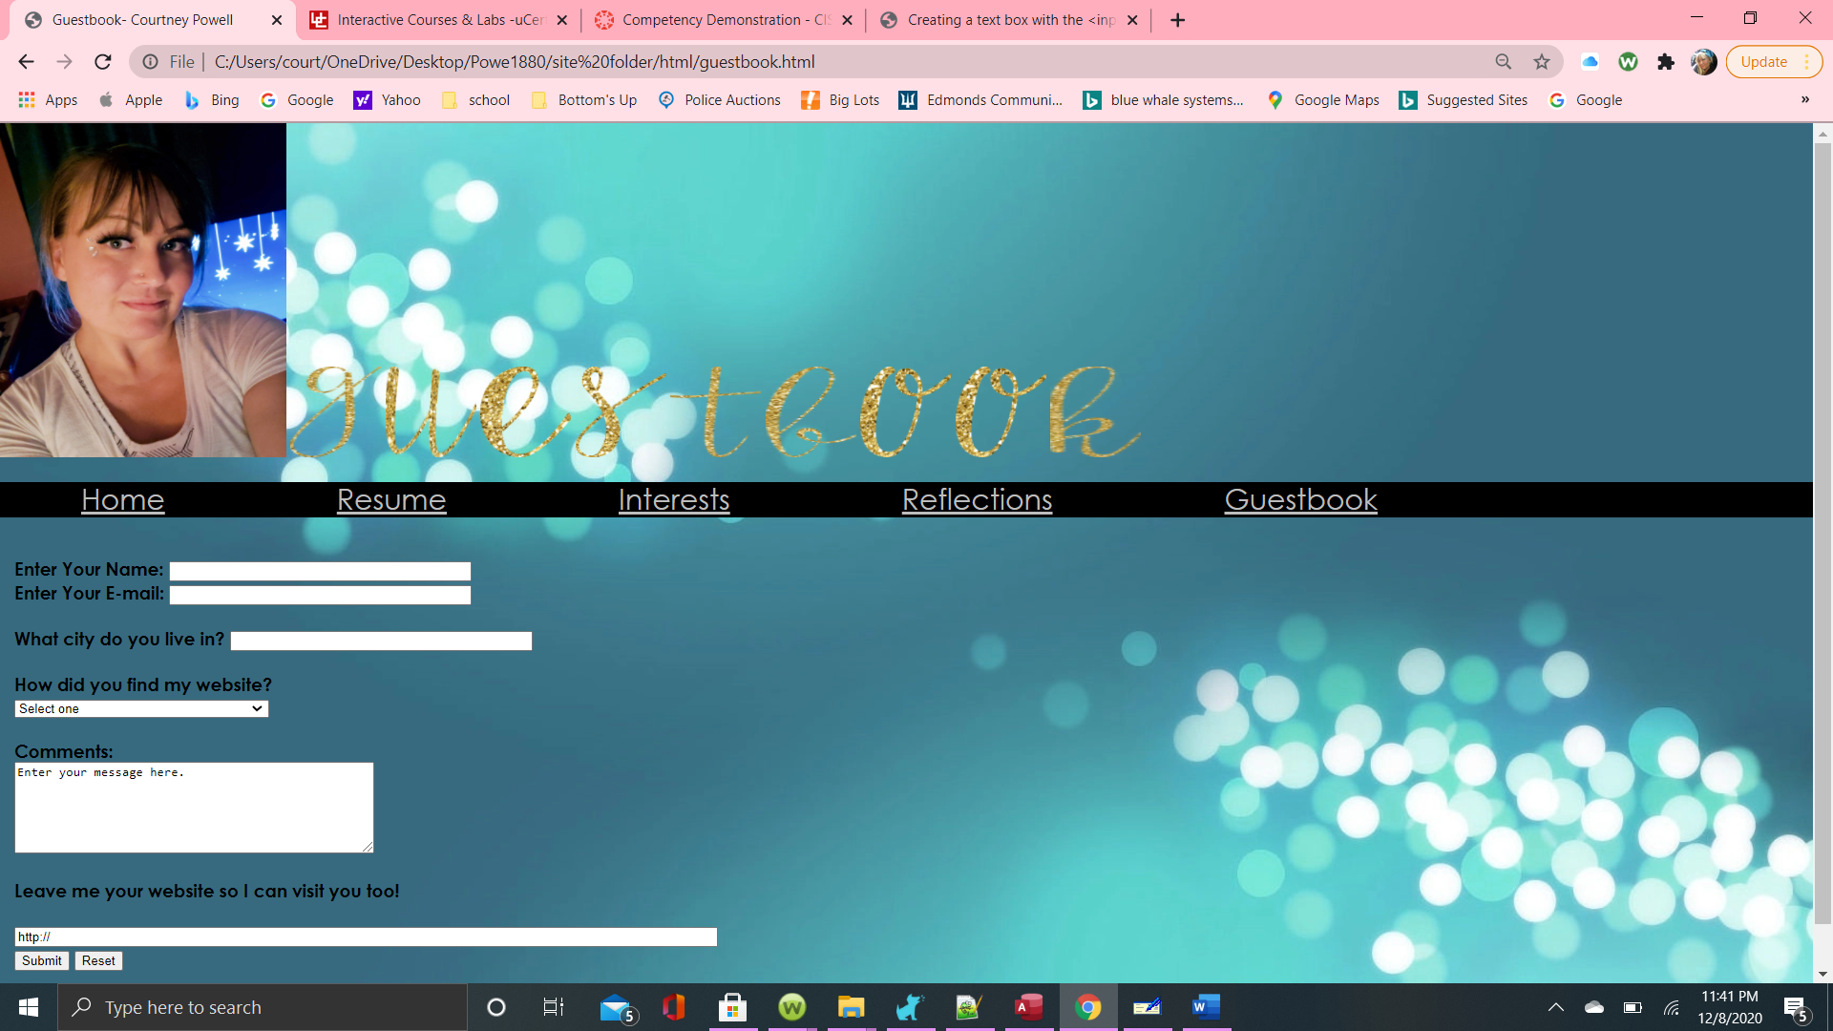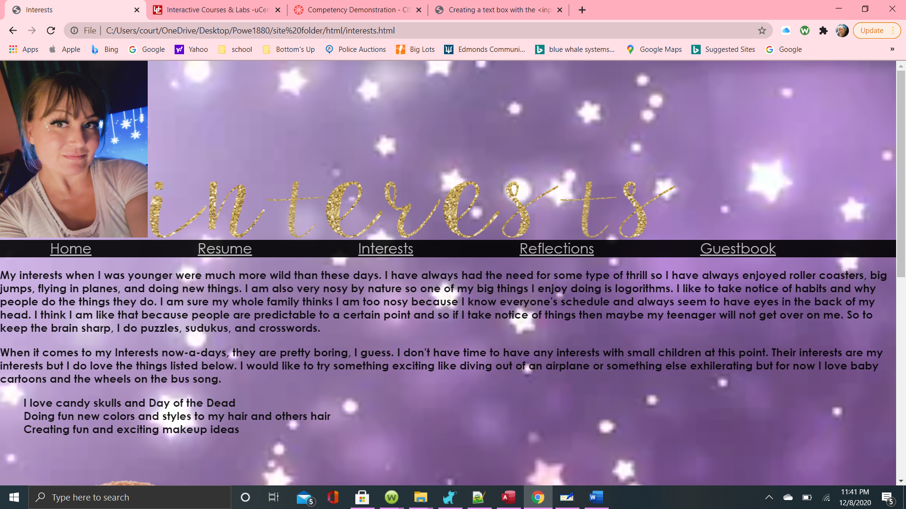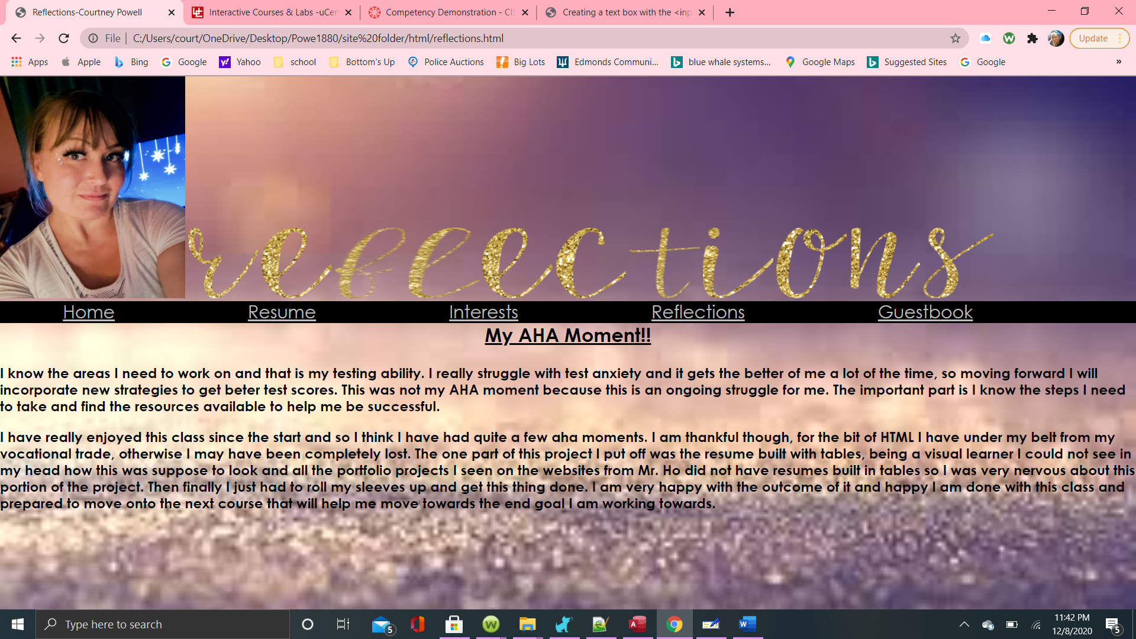

All the backgrounds favor each other and follow a color scheme I went with. Those are the glitter letters that I made on photoshop with a background and used the lasso and the pen to anchor out the shape of the letters.

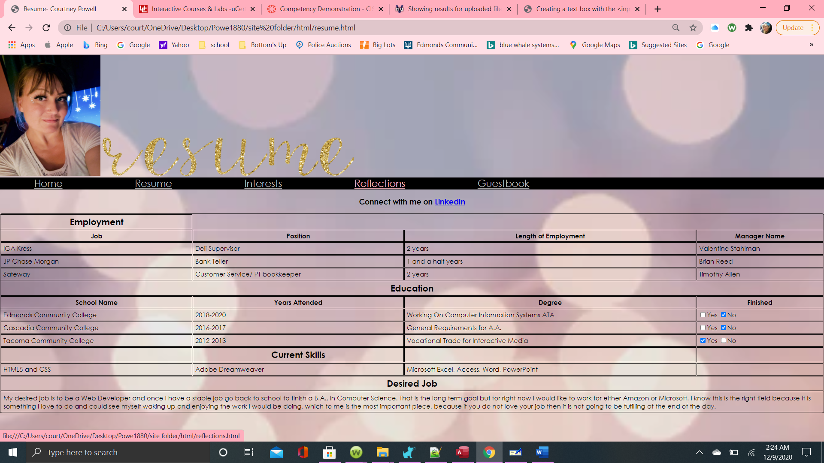

I like the way the resume page turned out I think it has the perfect look for looking professional. I